NodeJS provides the runtime environment to execute the Java Script code from outside the browser.

Node Package Manager(npm) can be used for managing and sharing the package for either or angular based project.

npm will be installed along with nodejs

Step1. Install NodeJS from nodejs.org

<https://nodejs.org/en/>

To ensure node js was installed in the system type the following in command prompt.

If it is successfully installed its version number will get displayed.

C:\Users\BYJUC>node --version

v14.17.1

C:\Users\BYJUC>node -v

v14.17.1

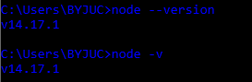

To know about npm version any of the following command is fine.

C:\Users\BYJUC>npm --version

7.19.1

C:\Users\BYJUC>npm -v

7.19.1

C:\Users\BYJUC>npm -version

7.19.1

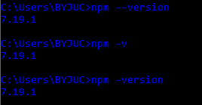

Part -2

Next Step is to install a tool named create-react-app.

This tool will be used to create react application

We can install this as a system level as well as folder level.

We will be installing globally using the below command

here -g stands for global.

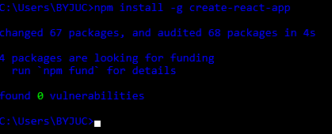

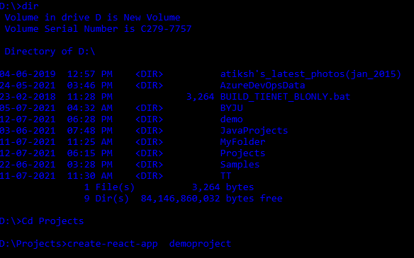

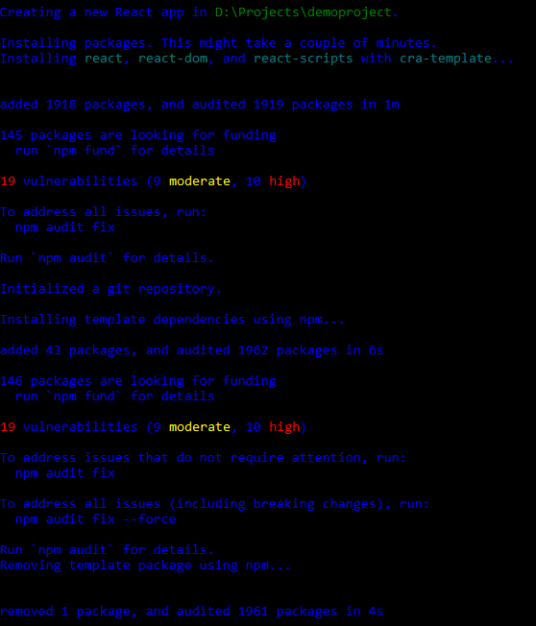

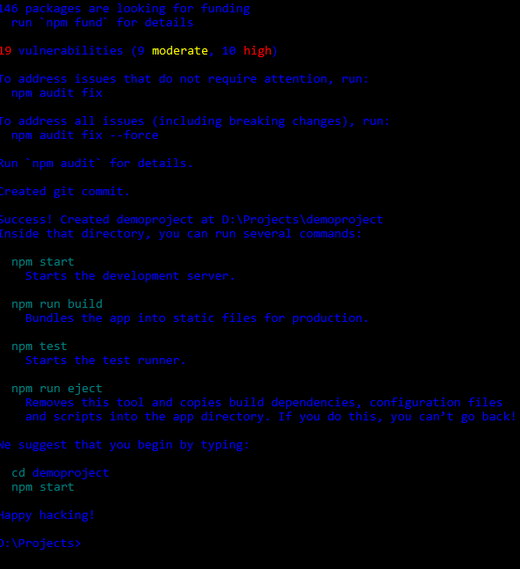

Go to project folder

and type

npm start

D:\Projects>cd demoproject

D:\Projects\demoproject>npm start

Application will get started in specified path

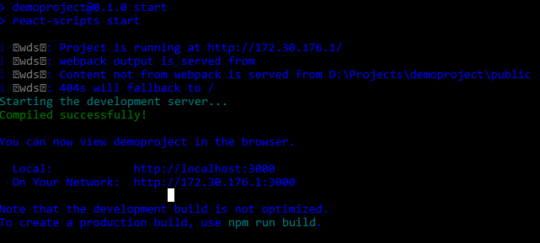

How to ?

Create and publish to GitHub Repository?

First go to github

<https://github.com/>

and create a repository. In this example we are using existing repository

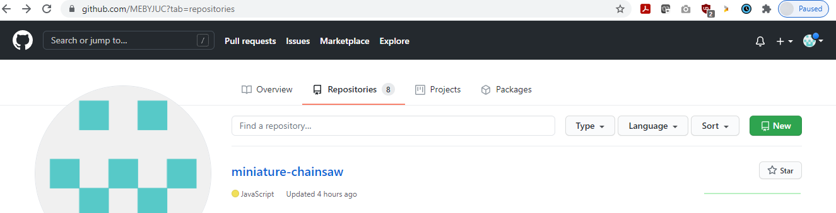

<https://github.com/MEBYJUC/miniature-chainsaw.git>

Go to the project folder, open the command prompt

before we continue further we need to remove every git releated files in this folder. for that type the following command

rd .git /S/Q



initiate a git repository under local repository. for that you type git init

D:\Projects\demoproject>git init

Initialized empty Git repository in D:/Projects/demoproject/.git/

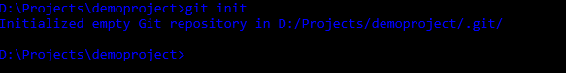

so .git file will be created as hidden file

to see that hidden file in command prompt type the following

D:\Projects\demoproject>attrib -s -h -r /s /d \*.\*



we add everything by adding git add command

D:\Projects\demoproject>git add .

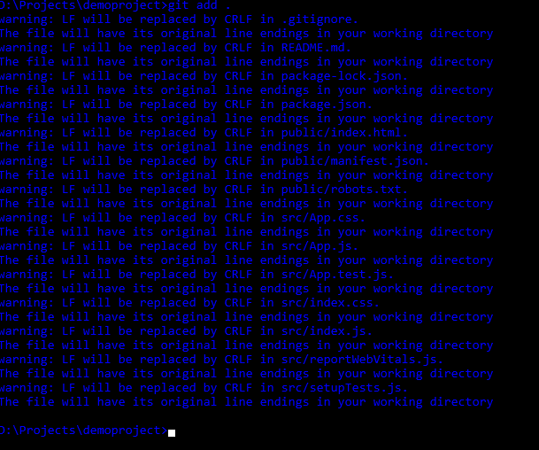

next step is we need to commit this file for that we need to add git commit command.

D:\Projects\demoproject>git commit -m "My First Commit "

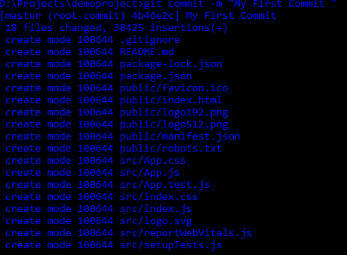

So we created GitHub reposiory which is empty for the moment and we create local git repository

next we need to configure these two with each other

To that we add git remote add origin <<github URL>>

https://github.com/MEBYJUC/miniature-chainsaw.git

D:\Projects\demoproject>git remote add origin https://github.com/MEBYJUC/miniature-chainsaw.git

D:\Projects\demoproject>



https://github.com/MEBYJUC/miniature-chainsaw.git

D:\Projects\demoproject>git remote add origin https://github.com/MEBYJUC/miniature-chainsaw.git

D:\Projects\demoproject>git push -u origin master